1.





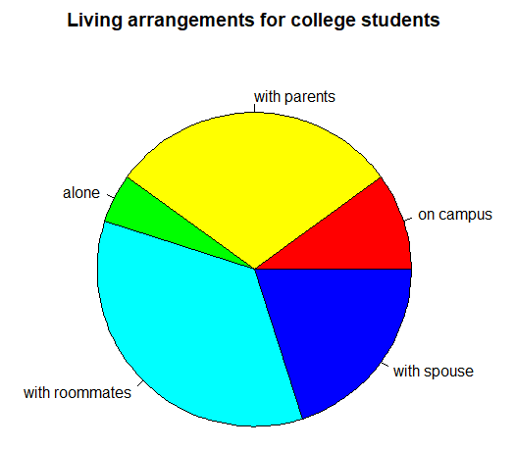

2.

3.





4.

5.

6. Based on the back-to-back stem plots for men’s and women’s heights, the one difference between the datasets that is immediately apparent is that women’s heights fall between 150cm and 178cm with a peak at 165-169cm creating a symmetrical data shape, while most men’s heights fall between 165cm and 193cm with a peak at 180-184cm, also creating a symmetrical data shape. Both group shares the same number of 6 ranges for each stem number.

7.

Based on the two frequency tables for female’s age and male’s age, the distribution of ages is very much similar between two genders. The most similar is at the age range from 15 to 20, where females and males are 88 students and 83 students respectively, which is not significantly different. For the age range between 20 and 25, female group has 8 students lesser than male, which is slightly a bigger gap between the 2 groups. For the older age ranges from 25 onwards, both genders have around 1-3 students for each range. There are no students from 45 to 70 of age for females and males, but there is one student for each group from 70-75 years old.

8.



9.

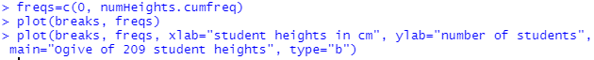

10.



11.



From the scatterplot of student’s heights and span of writing hand, taller students have wider span of writing hand as the height goes up, the width of writing hand goes up as well. For the scatter plot of student’s span of writing hand and non-writing hand, the spans for both hands are roughly the same, the wider their writing hand is, the wider their non-writing hand is. As for the scatterplot of student’s height and pulse rate, their heights don’t affect their heart rate as mostly all of them has pulse rate between 60 and 90 beats per minute. In general, student heights have positive correlation with the span of their writing hand and non-writing hand, but don’t have correlation with pulse rate as no matter how tall they are, their heart rate remains in the same range.